

Nuclear Fuel Cycle Demographic Analysis

March 2020



Table of Contents
Methodology 2
1.1 Overview 2
1.2 Uranium Recovery Facilities 3
1.3 Nuclear Reactor Facilities 4
1.4 Demographic Data 4
2 Results 5
2.1 1950 – 1980 6
2.2 1990 – 2010 9

Methodology

Overview
The goal of this project is to validate the assumption that the risk/reward for nuclear facilities are not equally distributed across socio-economic groups. The hypothesis is that high risk/low reward activities such as uranium mining and processing are located primarily in marginalized communities while high reward/ low risk activities such as nuclear reactor facilities are more commonly located in communities with a smaller marginalized population. While there are six primary stages of the fuel cycle, we will be examining, uranium recovery facilities and nuclear reactor facilities for this analysis. This is due to the lack of data availability in other areas of the fuel cycle. These sites are combined with census data to determine both the demographic conditions across sites at the time of siting, and how demographics changed after siting. Year of siting is defined as the first year of active production for a given facility. Inclusion for analysis looks at siting that occurred in 1950 to the present. The geographic scale used for analysis is the county. Counties were chosen as they are a relatively stable geography and census tracts were not available across the U.S. until 1990. Below is a flow chart of the methodological process.
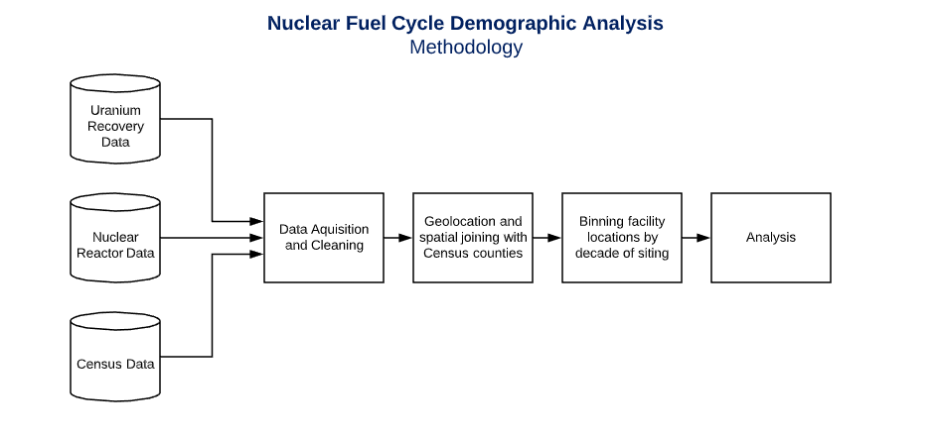

Uranium Recovery Facilities
Uranium recovery facilities includes both mining and milling facilities. The primary data source for this analysis is the USGS Mineral Resource Data System (MRDS) 2011 supplemented by EIA datasets to include more recent facilities. The MRDS data set was constrained for mines and mills located in the US, which were former or current producers (for mills), or mining activities that actively mined only uranium that included a first year of production field. Recovery facilities that mined several minerals were not included as reliable operating dates where needed to compare to socio-economic data and while uranium mining may have ceased other mining may have continued making date information unreliable. Below are the distribution of the resulting data set by state and year of siting.
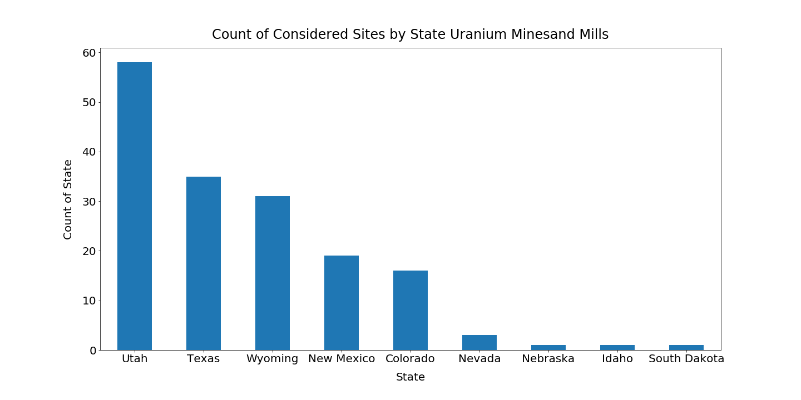

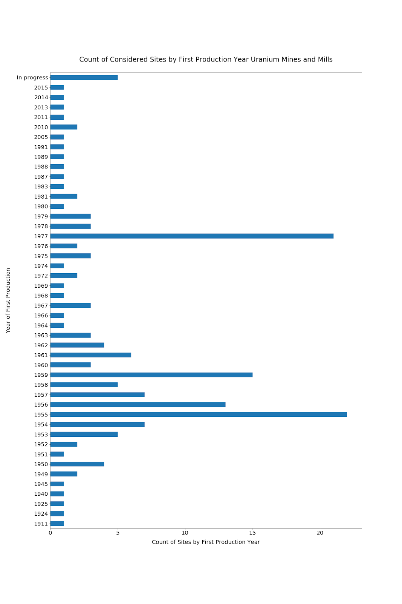

Nuclear Reactor Facilities

Nuclear Reactor facilities include all nuclear reactor facilities that were operational, excluding test reactors. The data source for this analysis is EIA -860 as of December 2019. This source includes all facilities that were still operating 2002 forward. If a facility was retired before 2002 it would not be included.

Demographic Data

Demographic data is drawn from U.S. Decennial Census from 1950-2010. Some demographic information also is drawn from the 2008-2012 ACS if needed datasets were unavailable. The geographic scale is the county level. The counties were derived from the 1950 Tiger Lines. Counties are a relatively stable geography however, they can change over time. Of the 103 counties included in this analysis, only one county changed its geography between 1950 and 2010. Valencia County in New Mexico, became 20% geographically smaller on the eastern side in 2010 when compared to 1950. However, it still encompassed the facility within it, The Rio Puerco Mine.

Results

After 1980’s the climate for nuclear energy changed substantially. Part of this was the accidents at Three Mile Island and Chernobyl which shifted nuclear sentiment toward building new reactor facilities. Conventional mining activities in the US ceased by 2002, both in response to the nuclear sentiment as well as the higher cost of uranium recovery in the US compared to Canada and Australia. Beginning in the 2000s, the uranium mining industry, with the introduction of new methods such as heap leaching and in situ leaching has seen growth. However, the low number of sited facilities from 1990 – 2010 necessitated a separate analysis from the sites sited from 1950 -1990.
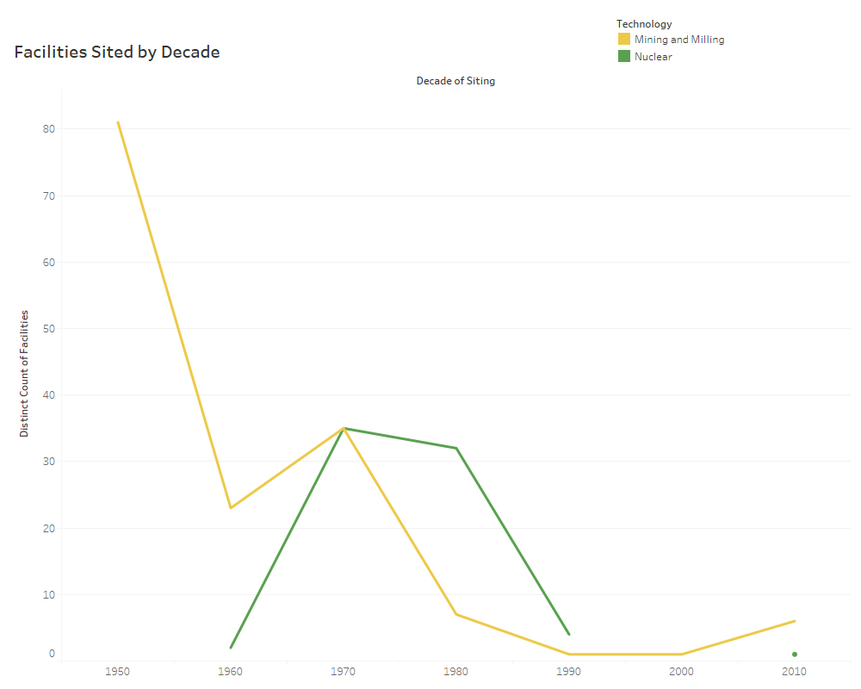

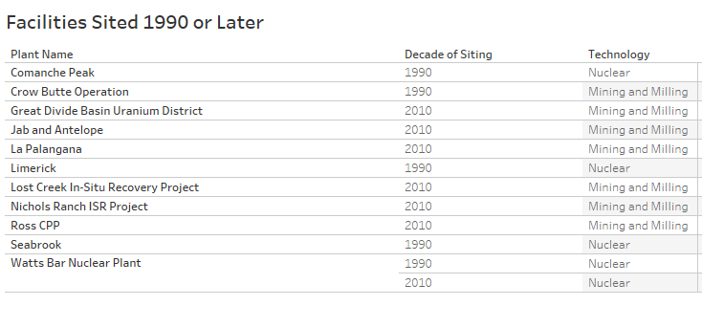

1950 – 1980
The analysis for this time period compared the difference in demographics at the county level for nuclear reactor facilities and uranium extraction facilities (mining and milling) both at the time of siting and in the decades following siting. The following trends emerged:
- The percentage of white population in both groups were similar at the time of siting, however in decades after siting the white population dropped substantially in counties that housed extraction facilities while counties that housed reactor facilities stayed more consistent
- Counties that housed extraction facilities had much higher percentages of the population that were Native American and Latino and Hispanic at the time of siting and these demographic populations also grew at a faster rate in subsequent decades.
- Counties that housed nuclear reactor facilities had higher Black and African American populations than counties with extraction facilities at the time of siting. However, African American populations in counties with nuclear reactor facilities declined or were stable over time. In counties with extraction facilities the population of African Americans increased.
- The percentage of population living below the poverty line is considerably higher in counties with extraction facilities than those counties with nuclear reactor facilities both at time of sitting and in subsequent decades.
- The percentage of the population with a bachelor’s degree or higher is larger in counties with nuclear reactor facilities than in those with extraction facilities.
The overall percentage of marginalized populations is higher in counties with extraction facilities than in those counties with nuclear reactor facilities at the time of siting. The siting of extraction facilities however appears to create a demographic shift over time as more marginalized populations move into these counties post siting, and more advantaged groups move out. This is in contrast with counties with nuclear facilities where demographics are much more stable over time.
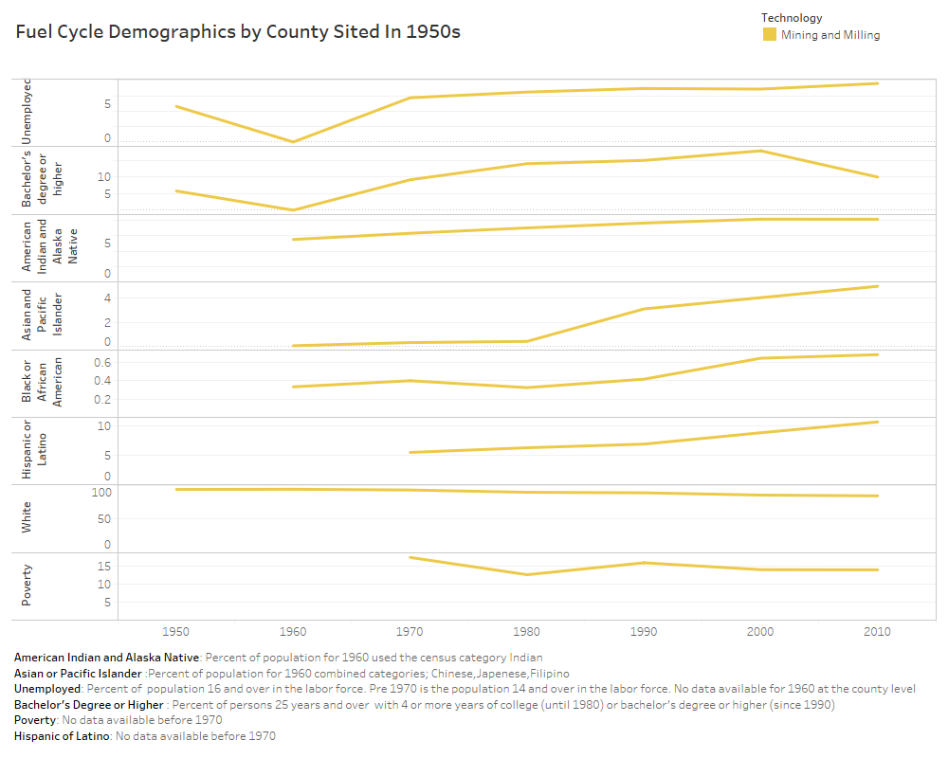
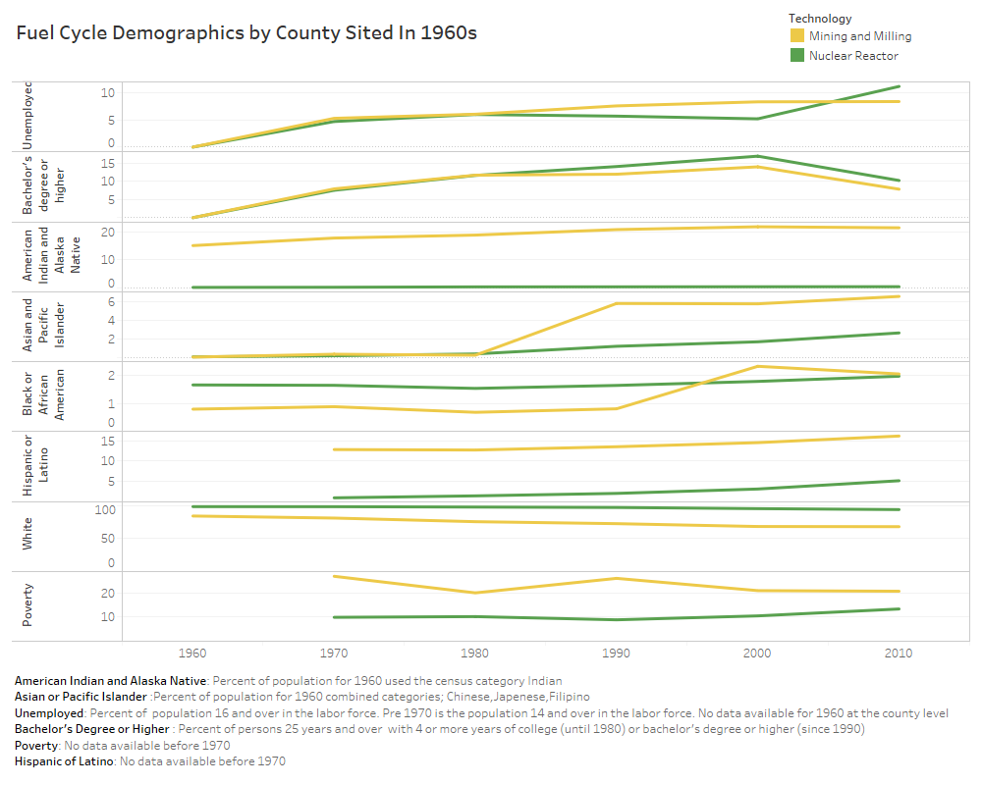
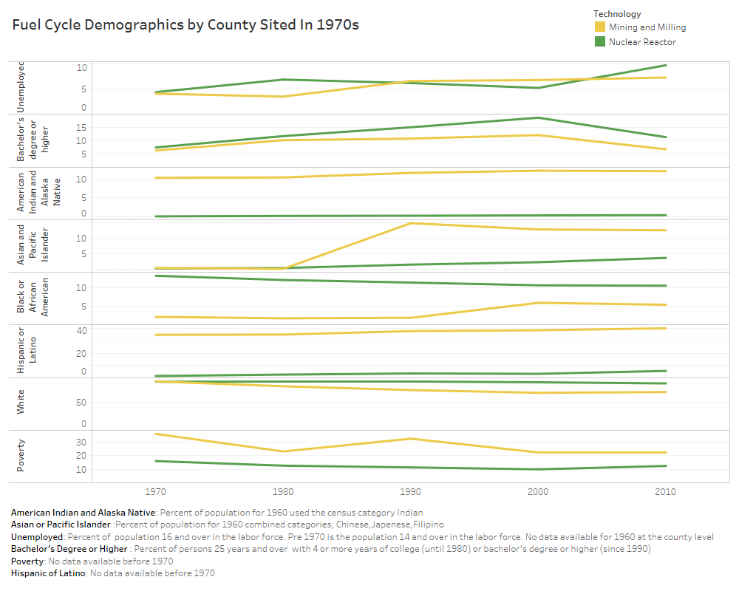
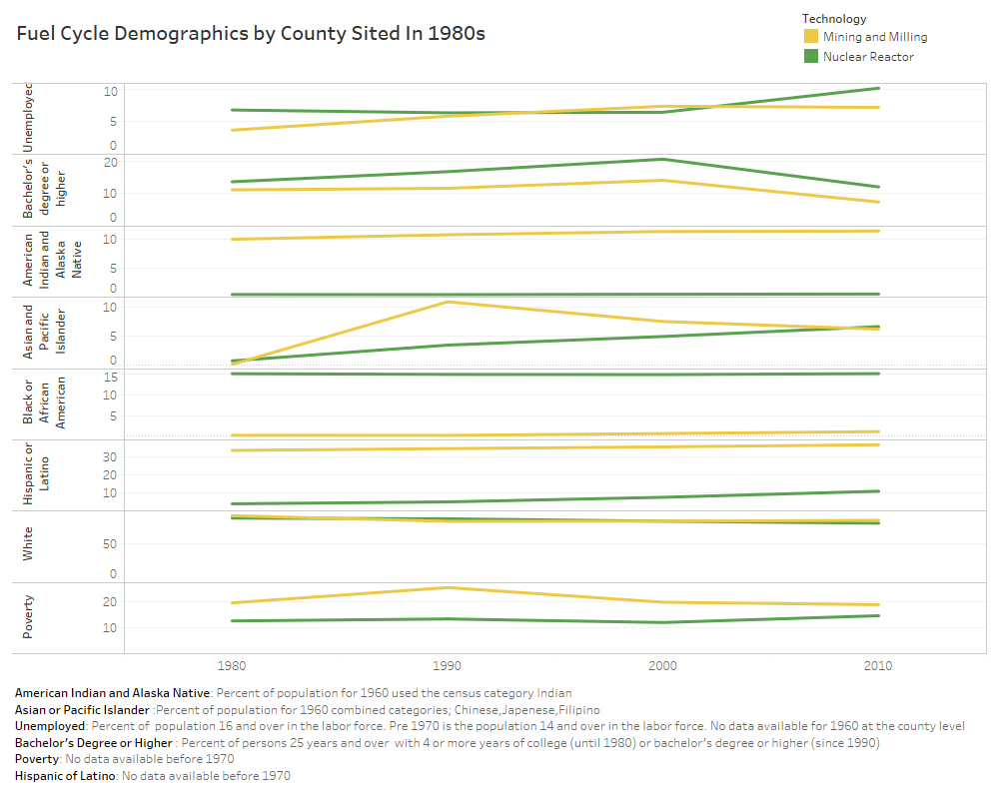

1990 – 2010
There is limited data to analyze siting between 1990 – 2010. This small sample size makes generalization difficult however, some of the same trends are apparent. The trends that emerged are:
- A higher percentage of Native American people live in the same counties as mining/milling facilities
- A higher percentage of Hispanic or Latino people live in the same counties as mining/milling facilities
- A higher percentage of college educated people live in the same counties as nuclear power facilities
- Poverty is higher in the same counties as mining/milling facilities

